2024-2025 Term 2 Sample Paper  Computer Literacy  Form 3  Carmel Holy Word Secondary School  2024 – 2025 Term 2 Sample Paper  Secondary 3 Computer Literacy  Question Book  Date : 29th May 2025  Time Limit : 30 minutes  Pages : 7  Total mark : 40  Instructions:  - You should write your name, class, class number and the examination venue in the spaces provided on Page 1 after the examination start announcement is made.  - There are three sections, A, B and C, in this Paper.  - ANSWER ALL QUESTIONS. Answers to Section A, B and C should be written in the answer sheet provided. | Name  Class  Class No.  Venue  By Markers  Total / 40
Section A: Multiple Choice Questions (15 marks)
Choose the most suitable answers.

1. What is the output of the following program?
print("I don\"t know.")
A. I don\"t know.
B. I don"t know.
C. I don't know.
D. This program cannot be compiled.

2. Which of the following codes can be compiled successfully?
A. 4you = Jesus
B. class = "3E"
C. _value_3 = 3
D. my-var = 30

3. What is the output of the following program?
i = "2"
j = int(i + i)
print(j * 2)

A. 2222
B. 84
C. 66
D. 44

4. Read the following program.

A = input()
B = input()
print(A + " and " + B + " are best friends.")
Input the following text in the program in order:
Peter
John
What is the output of the program in the terminal?
A. Peter and John are best friends.
B. A and B are best friends.
C. John and Peter are best friends.
D. This program cannot be compiled.

5. Read the following program.

n = int(input())
print(str(n * 2) + str(n ** 2))
Input the following text in the program:
3
What is the output of the program in the terminal?
A. 69
B. 39
C. 36
D. 66
6. Which of the following codes cannot print text Z2026 in the terminal?
A. print("Z" + 2026)
B. print("Z" + str(20 * 100 + 26))
C. print("Z" + str("2026"))
D. print("Z" + str(2026))

7. Read the following program.

A = input()
B = A + input()
print(A + B)
Input the following text in the program in order:
K
A
What is the output of the program in the terminal?
A. KAK
B. KKA
C. AKA
D. AKK

8. Read the following program.

a = int(input())
b = int(input())
print((a % 5) + b)
Input the following text in the program in order:
10
20
What is the output of the program in the terminal?
A. 10
B. 20
C. 30
D. 40

9. What is the output of the following program?
num = 150
if num > 100:
num = num - 10
elif num >= 100:
num = num - 5
print(num)

A. 150
B. 145
C. 140
D. 135

10. What is the output of the following program?
x = 2
while x < 20:
x = x * 2
print(x)

A. 16
B. 32
C. 20
D. 2

11. What does the following code output?

import random
print(random.randint(5, 7))

A. Always prints 6
B. Always prints 4 or 8
C. Prints a random integer: 5, 6, or 7
D. Error because randint() cannot be used

12. What library does the following code require to work?

sr.Recognizer()

A. gTTS
B. OpenCV
C. GoogleCloudTranslate
D. SpeechRecognition

13. What is the purpose of cv2.imshow() do?

A. Displays a video/image window
B. Converts image to grayscale
C. Translates text
D. Records speech

14. Which of the following is correct about GoogleCloudTranslate?
A. It converts text to mp3 audio
B. It needs internet access
C. It requires playsound to play audio
D. It can translate text into Chinese

15. Which line captures audio from the user?
A. cv2.VideoCapture(0)
B. tts.save("test.mp3")
C. recognizer.listen(source)
D. client.translate("Hi")

Section B: Short Questions (15 marks)
All answers should be written in the spaces provided in the answer sheet.

1. Complete the following program to open and show an image using OpenCV. (5 marks)

cv2 imread imshow waitKey destroyAllWindows

import ____(i)____
img = cv2.____(ii)____("sample.jpg")
cv2.____(iii)____("Preview", img)
cv2.____(iv)____(0)
cv2.____(v)____()

2. Complete the code to make the computer say what the user types using TTS. (5 marks)

gtts gTTS save input playsound

from gtts import ____(i)____
from playsound import ____(ii)____
text = ____(iii)____("Say something: ")
tts = gTTS(text, lang="en")
tts.___(iv)_____("voice.mp3")
____(v)____("voice.mp3")

3. Complete the code for translating a user-inputted sentence from Chinese to English using Google Cloud Translate. (5 marks)

Client result input zh en

from google.cloud import translate_v2 as translate
import os
os.environ["GOOGLE_APPLICATION_CREDENTIALS"] = "translate.json"
client = translate.____(i)____()
text = ____(ii)____("請輸入中文句子：")
____(iii)____ = client.translate(text,
source_language="____(iv)____",
target_language="____(v)____")
print(result["translatedText"])

Section C: Long Question (10 marks)
1. You are given the following program that performs three separate tasks using Python. Each part contains a bug or missing logic.
Line | Program
1  2  3  4  5  6  7  8  9  10  11  12  13  14  15  16  17 | # Part A  import random  print("A random number is:")  print(random.randint())  # Part B  from gtts import gTTS  tts = gTTS("Good job", lang="en")  tts.save()  print("Audio saved.")  # Part C  import cv2  cap = cv2.VideoCapture("lesson.mp4")  ret, frame = cap.read()  cv2.imshow(frame, "Video Frame")  cv2.waitKey(0)

(a) Identify and correct one error or problem in each part. (6 marks)

(b) Write a complete and correct program to do the following task: (4 marks)

  - Ask the user to input a number
  - Multiply the number by 10
  - Speak out the result using gTTS
  - The program must save and play the voice

End of Paper

Carmel Holy Word Secondary School
/40
2nd Term Sample Paper 2024 - 2025
Secondary 3 Computer Literacy
Answer Sheet
Name : Time allowed : 30 minutes

Section A: Multiple Choice Questions (15 marks)
Choose the most suitable answers. Use an HB pencil to blacken the circle next to the question numbers below.
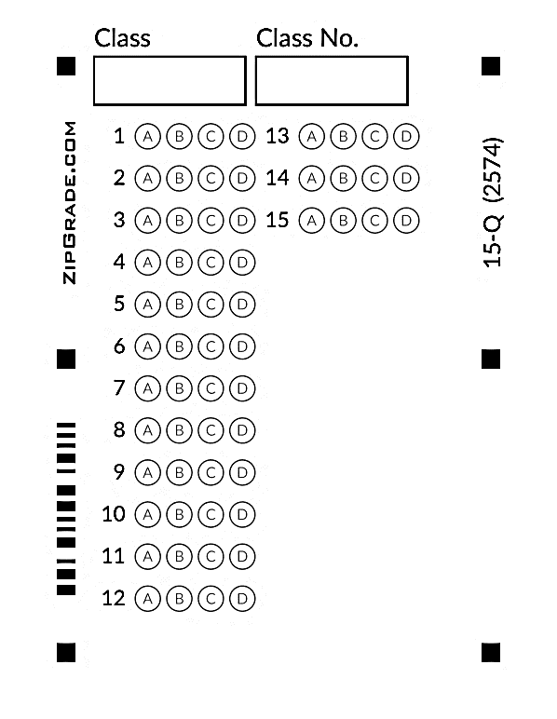
Section B: Short Questions (15 marks)
All answers should be written in the spaces provided.

1. | (i) | (ii) | (iii)
 | (iv) | (v)

2. | (i) | (ii) | (iii)
 | (iv) | (v)

3. | (i) | (ii) | (iii)
 | (iv) | (v)

Section C: Long Question (10 marks)

1. (a) Part A:
Error: ______________________________________
Correction: _________________________________

Part B:
Error: ______________________________________
Correction: _________________________________

Part C:
Error: ______________________________________
Correction: _________________________________
(b)

End of Paper

2024-2025 Term 1 S3 CMP Sample Paper
Suggested Answer
Section A: @ 1mark
BCDAA ABBCB CDADC

Section B:

1. | (i) cv2 | (ii) imread | (iii) imshow
 | (iv) waitKey | (v) destroyAllWindows

2. | (i) gTTS | (ii) playsound | (iii) input
 | (iv) save | (v) playsound

3. | (i) Client | (ii) input | (iii) result
 | (iv) zh | (v) en

Section C:

1. (a) Part A
Error: random.randint() requires two arguments (start, end)
Correction: random.randint(1, 10) or any two integers
Part B
Error: tts.save() is missing filename argument
Correction: tts.save("output.mp3")
Part C
Error: Incorrect argument order in cv2.imshow()
Correction: cv2.imshow("Video Frame", frame)

(b) from gtts import gTTS
from playsound import playsound

number = int(input("Enter a number: "))
result = number * 10
tts = gTTS("The result is " + str(result), lang="en")
tts.save("result.mp3")
playsound("result.mp3")

